10th October 2016

Lexus Takes first VLN victory to Asia – and YOKOHAMA

The Farnbacher team achieved a sensational result for themselves, Lexus and the Japanese Tyre manufacturer YOKOHAMA. Five years after the crew, managed by Horst Farnbacher took the first victory with Ferrari in the VLN endurance championship Nürburgring, the team which is based in Lichtenau, Germany managed a fantastic win during the 9th round of the 2016 VLN Championship.

On their Lexus RC-F GT Prototype, Dominik and Mario Farnbacher also made history taking the first victory for a car manufacturer from Asia. After 28 laps they managed crossing the finish line 33.551 seconds ahead of second qualified Alexander Sims and Stef Dusseldorp on a BMW M6 GT3 of ROWE-Racing.

“This is a fantastic result and the reward for so much hard work for almost two years”, stated a delighted Horst Farnbacher after the race.

At the legendary Nürburgring Nordschleife race track, considered by many around the world as the most demanding of all, to succeed at the “Green Hell” means instant recognition and reputation especially in Japan.

Jubilant scenes at the pit wall by the teams involved and representatives of the racing team, Toyota, Lexus and YOKOHAMA celebrated the result.

Mario Farnbacher went on to add the result had not been by chance but rather good collaboration and effort between the racing team and constant communication with their partners in Japan.

Strategy also played an important part as the team changed from wet to dry tyres in the second lap and the consistency shown by the drivers who did not make any mistakes throughout the four hours race even in the challenging weather conditions.

The season finale of the VLN endurance championship Nürburgring will take place on 22nd October.

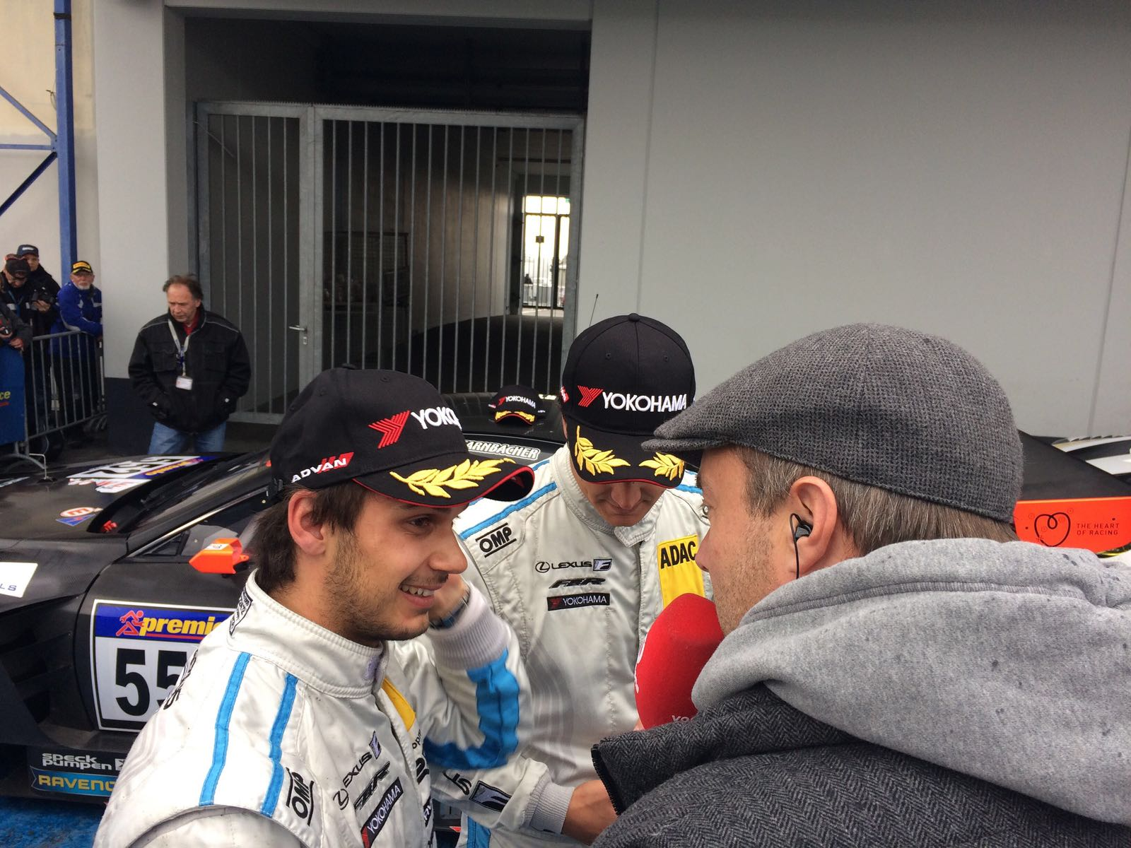
Media interest in the winning drivers at VLN

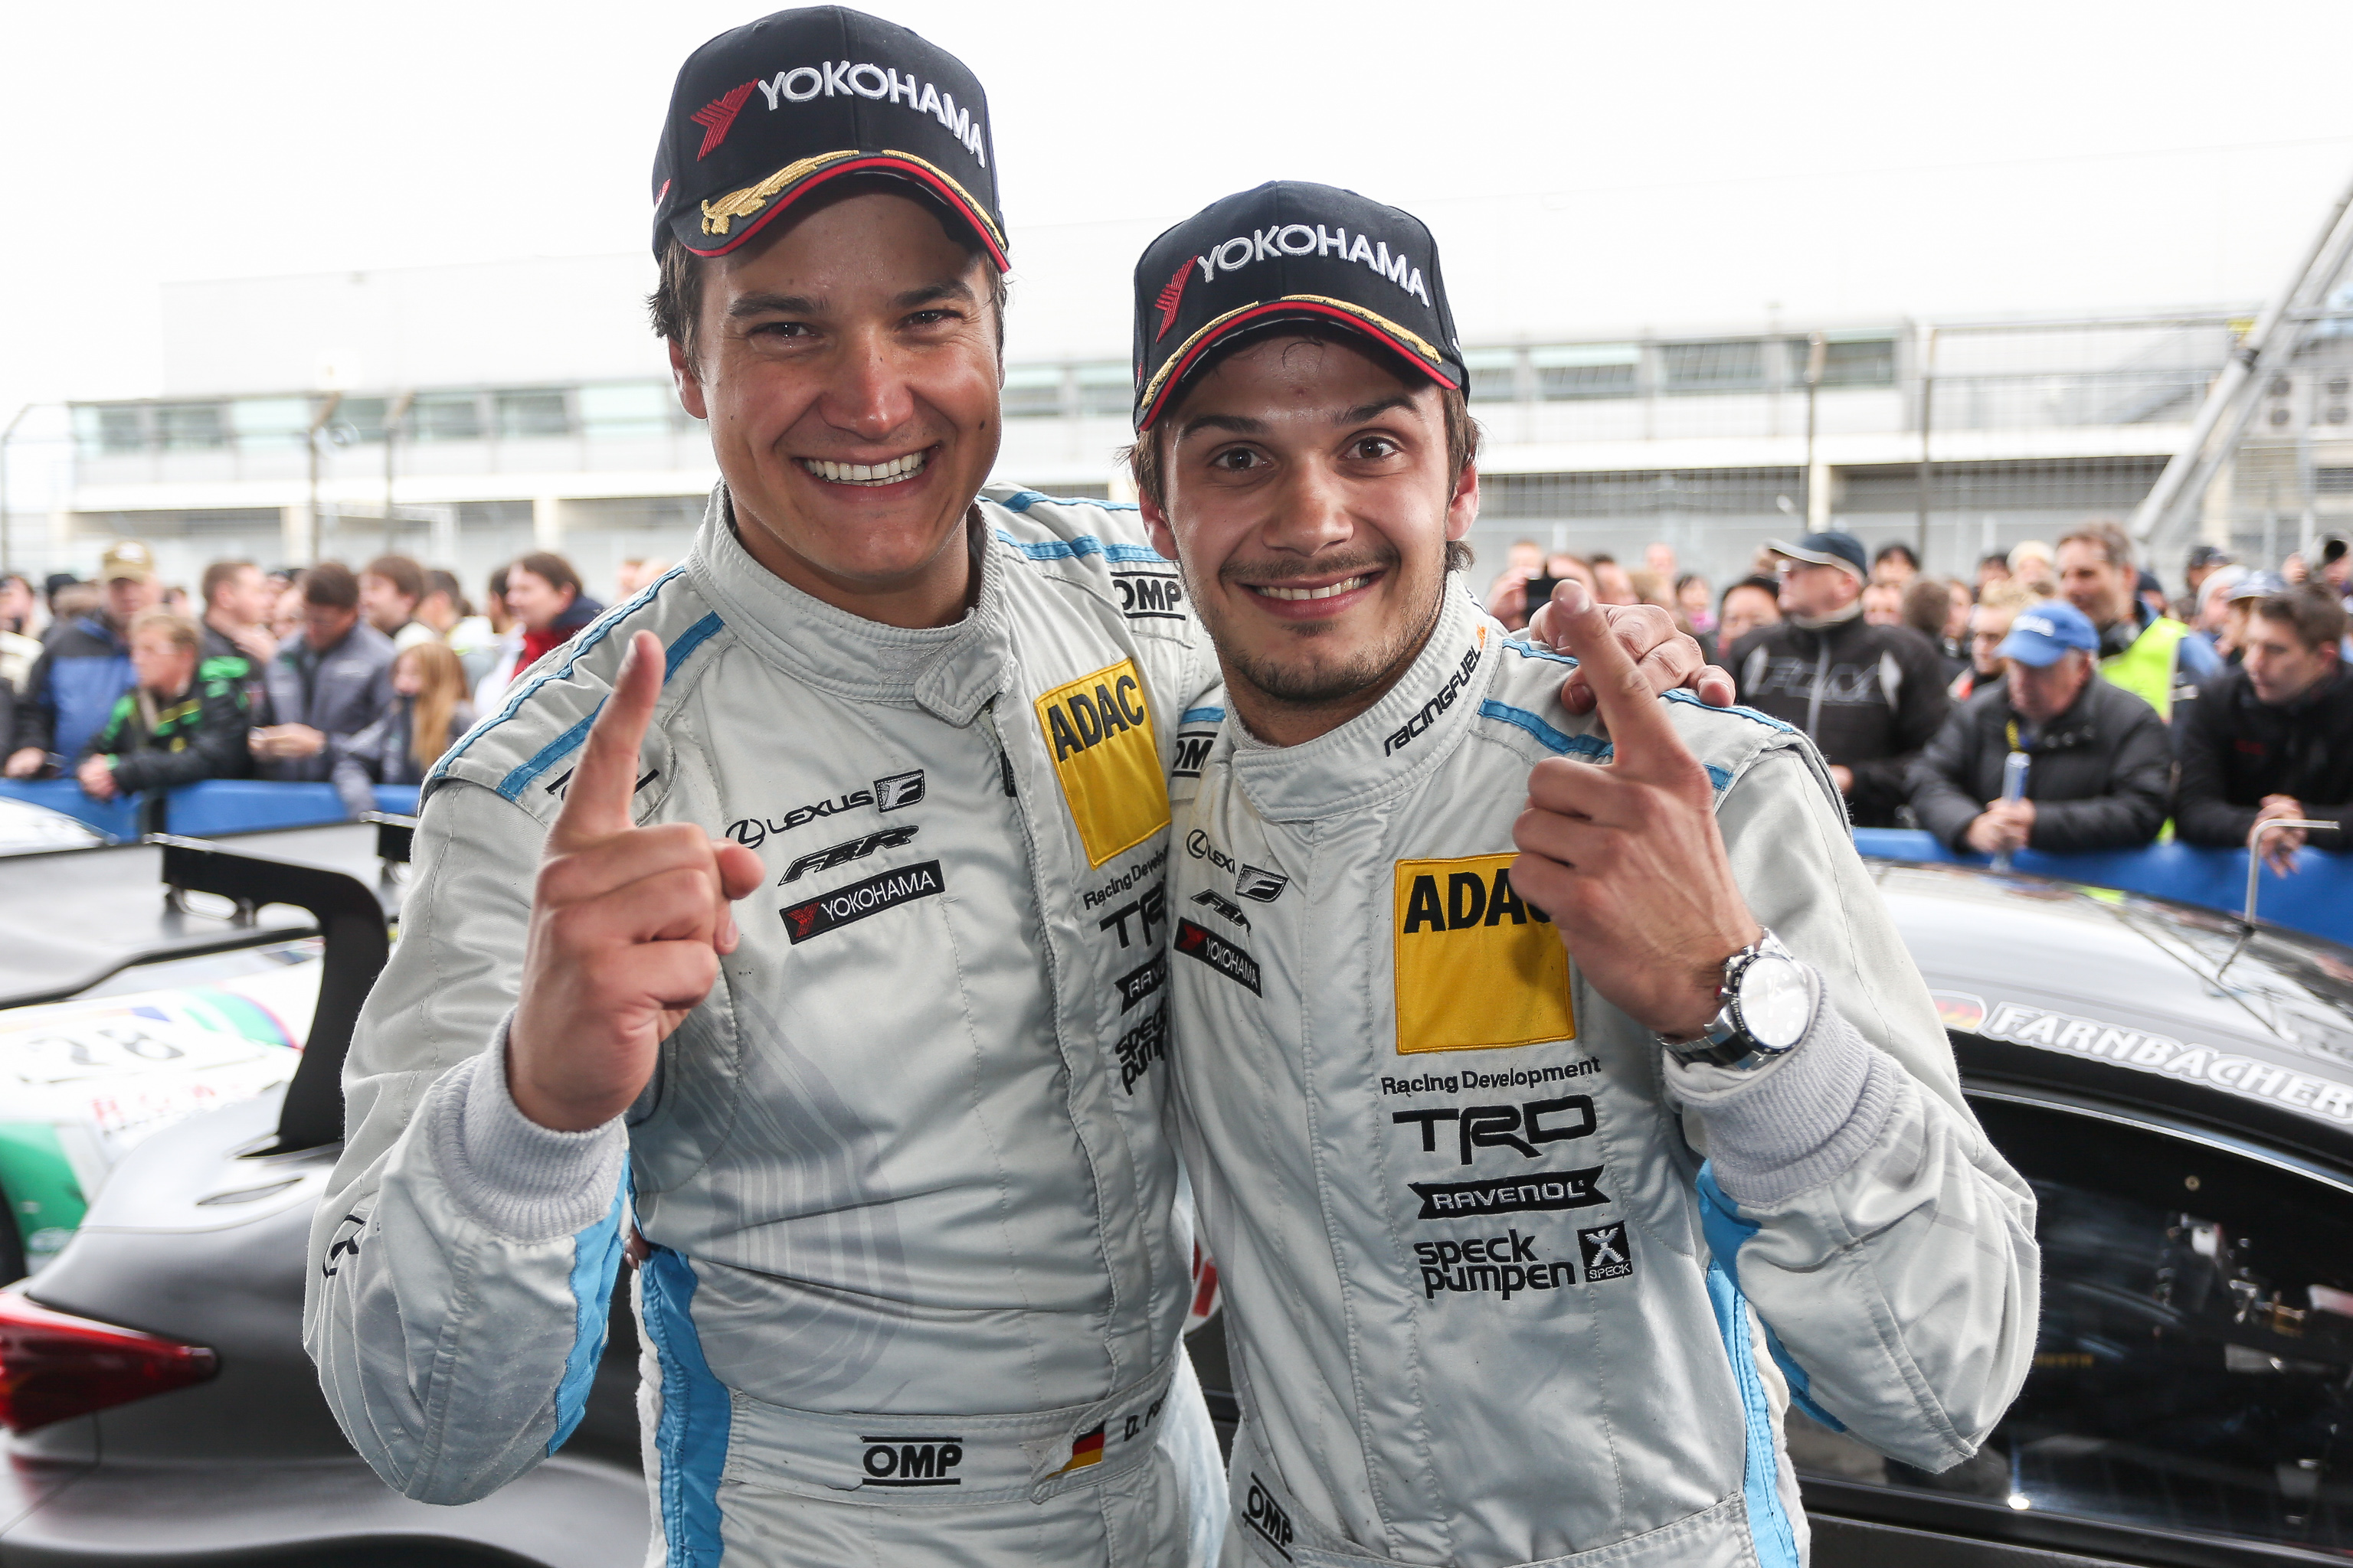
Team Farnbacher celebrate victory at VLN Endurance Championship

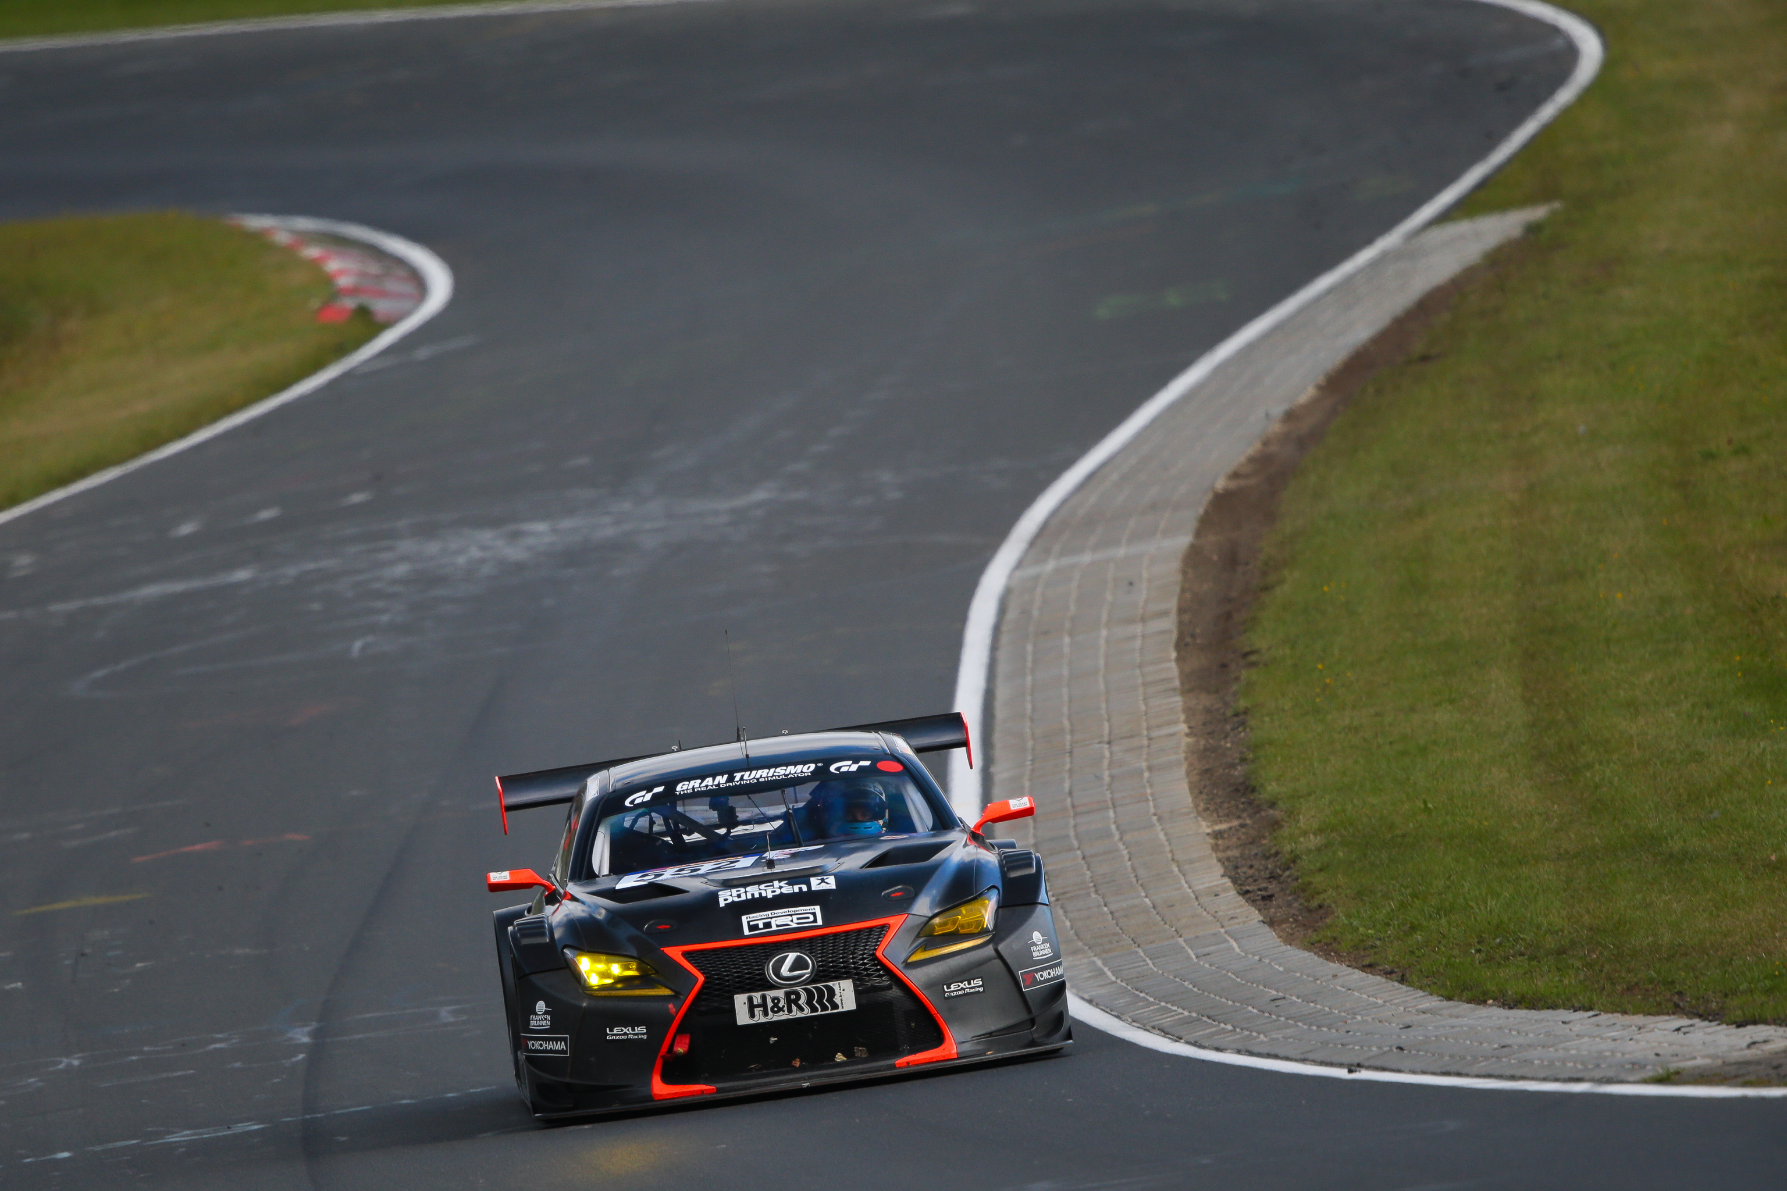
VLN- Farnbacher Racing team Lexus with YOKOHAMA at the Green Hell

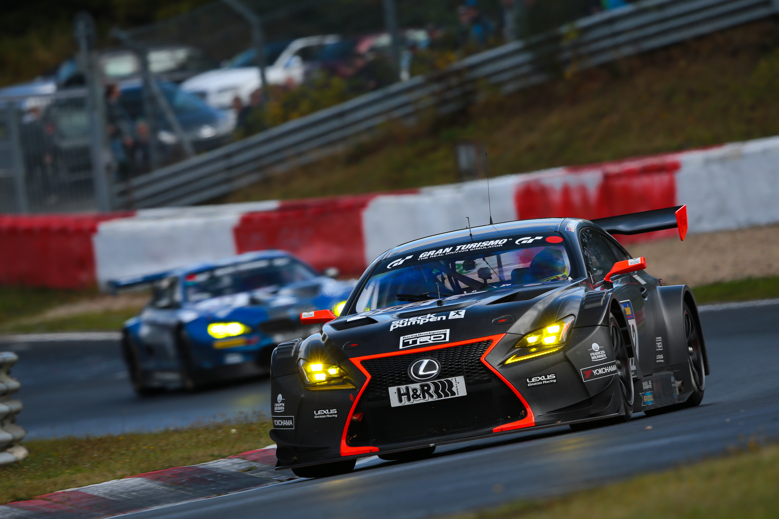
VLN-Winning Lexus on Yokohama tyres

